**Swiper Sliders Bundle**

Swiper sliders bundle is a collection of various sorts of sliders built with Swiper JS.

**Bundle Features:**

* Build with HTML5, CSS3, JavaScript and Swiper JS
* Easy to customize
* Compatible with all modern browsers
* Simple to integrate into websites, web apps, and mobile native/hybrid apps
* W3C Validated Code

**Zip folder contains:**

1. asset – Images
2. main.css
3. index.html

**Folder structure:**

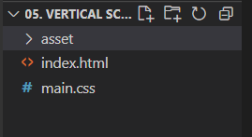

**CSS:**

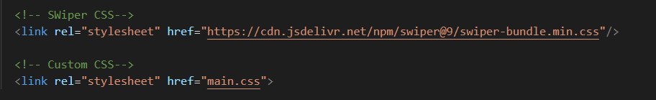

**JS:**

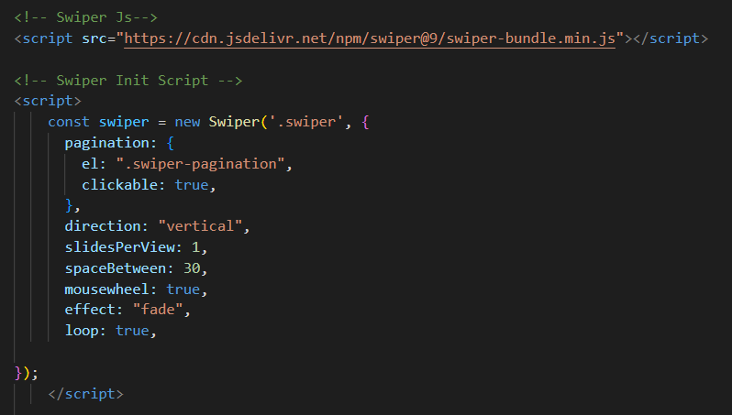

**Other Information:**

1. Sliders are built with [**Swiper JS**](https://swiperjs.com/) **Version 9.2.4**
2. Copyright free images are used from [**Pixabay**](https://pixabay.com/images/)

**Support:**

If you have any questions don't hesitate to reach us at [vigowebs@gmail.com](mailto:vigowebs@gmail.com)